Class Assignment 2: Web Server(Assignment)

In this lab, you will learn the basics of socket programming for TCP connections: how to [M1] create a socket, bind it to a specific address and port, as well as [M2] [M3] send and receive a HTTP packet. You will also learn some [M4] basics of HTTP header format.

You will [M1] develop a web server that handles one HTTP request at a time. Your web server should [M2] accept and parse the HTTP request, get the requested file from the server’s file system, [M3] create an HTTP response message consisting of the requested file preceded by [M4] header lines, and then send the response directly to the client. If the requested file is not present in the server, the server should send an HTTP “404 Not Found” message back to the client.

We are going to implement version 1.0 of HTTP, as defined in RFC 1945, where separate HTTP requests are sent for each component of the Web page. The server will be able to handle multiple simultaneous service requests in parallel. This means that the Web server is multi-threaded.

- Mission 0: Before Start the Following Missions
  - Draw Block diagram of Web Server
  - Draw Flow chart for Web Server & Web Client
- Mission 1: Handle Connection. create and bind a socket.
  - handles one HTTP request at a time
  - And also, HTTP should handle several request at a time.
[Web server should be multithreaded → Why?]
- Mission 2: parse the HTTP request
  - HTTP server should handle the method (GET, POST, …)
  - HTTP server should recognize the URL.
  - HTTP server should recognize the version.
- Mission 3: create an HTTP response message consisting of the requested file preceded by header lines,
  - send the response “200 OK” and appropriate message directly to the client(get the requested file from the server’s file system)
  - If the requested file is not present in the server, the server should send an HTTP “404 Not Found” message back to the client.
  - If the request message is not proper(version), the server should send an HTTP “400 BAD REQUEST” message back to the client.
- Mission 4: create an HTTP response message with header lines,
  - Handle extra HTTP header: Content-type

Code
Below you will find the skeleton code for the Web server. You are to complete the skeleton code. The places where you need to fill in code are marked with #Fill in start and #Fill in end. Each place may require one or more lines of code.

Keys to solve [Please Check with Wireshark]
It is very Important with check with correct HTTP protocol Request and Response
Correct HTTP Request and Response: Image File Request and Response
HTTP Get Request format
GET /index.html HTTP/1.1\r\n
Host: www-net.cs.umass.edu\r\n
User-Agent: Firefox/3.6.10\r\n
Accept: text/html,application/xhtml+xml\r\n
Accept-Language: en-us,en;q=0.5\r\n
Accept-Encoding: gzip,deflate\r\n
Accept-Charset: ISO-8859-1,utf-8;q=0.7\r\n
Keep-Alive: 115\r\n
Connection: keep-alive\r\n
\r\n

HTTP Get Response
HTTP/1.1 200 OK\r\n
Date: Sun, 26 Sep 2010 20:09:20 GMT\r\n
Server: Apache/2.0.52 (CentOS)\r\n
Last-Modified: Tue, 30 Oct 2007 17:00:02 GMT\r\n
ETag: "17dc6-a5c-bf716880"\r\n
Accept-Ranges: bytes\r\n
Content-Length: 2652\r\n
Keep-Alive: timeout=10, max=100\r\n
Connection: Keep-Alive\r\n
Content-Type: text/html; charset=ISO-8859-1\r\n
\r\n
data data data data data ...

Running the Server

Put an HTML file (e.g., HelloWorld.html) in the same directory that the server is in. Run the server program. Determine the IP address of the host that is running the server (e.g., 128.238.251.26). From another host, open a browser and provide the corresponding URL. For example:

http://128.238.251.26:6789/HelloWorld.html

‘HelloWorld.html’ is the name of the file you placed in the server directory. Note also the use of the port number after the colon. You need to replace this port number with whatever port you have used in the server code. In the above example, we have used the port number 6789. The browser should then display the contents of HelloWorld.html. If you omit ":6789", the browser will assume port 80 and you will get the web page from the server only if your server is listening at port 80.

Then try to get a file that is not present at the server. You should get a “404 Not Found” message.

What to Hand in

You will hand in the complete server code along with the screen shots of your client browser, verifying that you actually receive the contents of the HTML file from the server.

Program Structure for Web Server
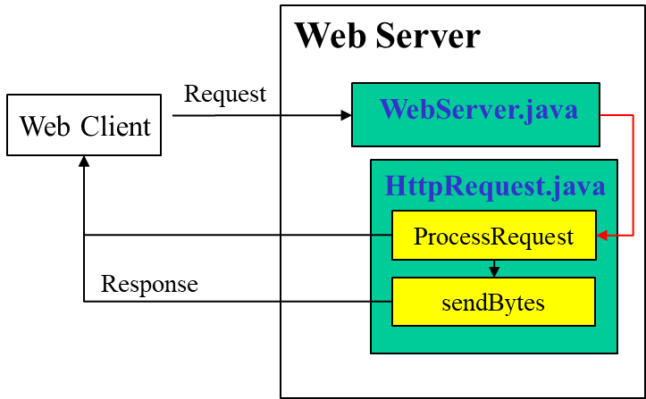

Skeleton Java Code for the Web Server
WebServer.java
/* Extension 1: */
import java.io.* ;
import java.net.* ;
import java.util.* ;

/**
* WebServer class implements a simple multi-threaded web server.
*
* This class serves as the main entry point for the web server application.
* Its primary responsibilities include:
* 1. Initializing the server on a specified port
* 2. Listening for incoming client connections
* 3. Creating new threads to handle each client request
*
* The server runs indefinitely, continuously accepting new connections
* and spawning threads to process HTTP requests.
*/
public final class WebServer {
public static void main(String argv[]) throws Exception {
// Check if command line argument for port number is provided
if(argv.length < 1){
System.out.println(“Usage: java WebServer <port number : >”);
return ;
}

// Get the port number from the command line.
int port = (new Integer(argv[0])).intValue();

// Mission 1(Handle Connection): create and bind a socket (Fill #1 ~ #2)
// Fill #1 Create the Serversocket and wait for the TCP Connection
// Establish the Serversocket wait for the TCP Connection
ServerSocket socket = /*Fill in the Blank*/

// Process HTTP service requests in an infinite loop.
while (true) {
// Fill #2 Listen for a TCP connection request.
/*Fill in the Blank*/
//Mission 1-B Fill #3 Construct an object to process the HTTP request message.
HttpRequest request = new HttpRequest(/*Fill in the Blank*/);
// Mission 1-BFill #4, Create a new thread to process the request and start the thread
/*Fill in the Blank*/ }
}
}

HttpRequest.java

import java.io.* ;
import java.net.* ;
import java.util.* ;

final class HttpRequest implements Runnable {
final static String CRLF = "\r\n";
Socket socket;

// Constructor
public HttpRequest(Socket socket) throws Exception {
this.socket = socket;
}

// Implement the run() method of the Runnable interface.
public void run() {
try {
processRequest();
} catch (Exception e) {
System.out.println(e);
}
}

/**
* ProcessRequest Method class handles HTTP Request Messages
* 1. Receive and send HTTP Request and HTTP Response
* 2. Parse HTTP request line and save
* 3. Parse HTTP Header line and save
*
* The server runs indefinitely, continuously accepting new connections
* and spawning threads to process HTTP requests.
*/
private void processRequest() throws Exception {
//Mission 2: parse the HTTP request (Fill #5 ~ #7)
// Fill#5 Create input stream from socket to receive data from client
// Fill#6 Create output stream via socket to send data to client
// Fill#7, bufferedReader filter around the input stream to parse HTTP Request
//to Get a reference to the socket's input and output streams.
// https://docs.oracle.com/javase/8/docs/api/java/io/package-summary.html
InputStream is = /*Fill in the Blank*/ //Mission 2: Get input stream from the socket
DataOutputStream os = /*Fill in the Blank*/ //Mission 2: Get Output stream from the socket

// Set up input stream filters.
BufferedReader br = /*Fill in the Blank*/ //Mission 2: wrap InputStreamReader and BufferedReader filters around the input stream

// Mission 2(2-A, 2-B, 2-C): parse the HTTP request (Fill #8 ~ #9)
String requestLine = /*Fill in the Blank*/ // Mission 2: Get the request line of the HTTP request message

// Fill #9: Use StringTokenizer to HTTP request
// StringTokenizer from Java.util
// https://docs.oracle.com/javase/8/docs/api/java/util/package-summary.html
/*Fill in the Blank*/
String method = /*Fill in the Blank*/ // Mission 2-A: Get method information, Optional Exercises
String fileName = /*Fill in the Blank*/ // Mission 2-B: Get URI information
String version = /*Fill in the Blank*/ // Mission 2-C: Get HTTP Version information

// Prepend a "." so that file request is within the current directory.
fileName = "." + fileName ;

// Open the requested file.
FileInputStream fis = null ;
boolean fileExists = true ;
try {
fis = new FileInputStream(fileName);
} catch (FileNotFoundException e) {
fileExists = false ;
}
// Debug info for private use
System.out.println("Incoming!!!");
System.out.println(requestLine);
String headerLine = null;
while ((headerLine = br.readLine()).length() != 0) {
System.out.println(headerLine);
}
// Construct the response message.
String statusLine = null;
String contentTypeLine = null;
String contentLengthLine = null;
String entityBody = null;

/**
* Mission 3. Analyze the request and send an appropriate response
* Mission 3. If HTTP response message consisting of the requested file, make the code with 200 OK
* If the requested file is not present in the server, the server should send an HTTP “404 Not Found” message back to the client.
* If the request message is not proper, the server should send an HTTP “400 BAD REQUEST” message back to the client.
* and make more response codes for your HTTP web server
* Optional Projects. Not only for the Method “GET”, you also have to consider handling other Methods.
*/
if (fileExists) {
//Fill#10. When requested file exists, Status Code 200 OK
statusLine = /*Fill in the Blank*/ // Mission 3-A: Status Code 200 OK
contentTypeLine = "Content-Type: " + contentType(fileName) + CRLF;
contentLengthLine = "Content-Length: " + getFileSizeBytes(fileName) + CRLF;

} else {
#Fill#11. When requested file doesn’t exist, Status Code 404 NOT FOUND
statusLine = /*Fill in the Blank*/ // Mission 3-B: Status Code 404 Not found
contentTypeLine = "Content-Type: text/html" + CRLF;
entityBody = "<HTML>" +
"<HEAD><TITLE>Not Found</TITLE></HEAD>" +
"<BODY>Not Found</BODY></HTML>";
}

//
/ Mission 3-C(option): Status Code 400 Bad Request
/*Fill in the Blank*/

// Send the status line.
os.writeBytes(statusLine);

// Send the content type line.
os.writeBytes(contentTypeLine);

// Send the content length line.
os.writeBytes(contentLengthLine);

// Send a blank line to indicate the end of the header lines.
os.writeBytes(CRLF);

// Send the entity body.
if (fileExists) {
sendBytes(fis, os);
fis.close();
} else {
os.writeBytes(/*Fill in the Blank*/) ; // Mission 3: Send appropriate entity body
}

// Close streams and socket.
os.close();
br.close();
socket.close();
}

/**
* Method which sends the context
* @param fis FileInputStream to transfer
* @param os outputstream to client
*/
private static void sendBytes(FileInputStream fis,
OutputStream os) throws Exception {
// Construct a 1K buffer to hold bytes on their way to the socket.
byte[] buffer = new byte[1024];
int bytes = 0;

// Copy requested file into the socket's output stream.
while ((bytes = fis.read(buffer)) != -1) {
os.write(buffer, 0, bytes);
}
}

/**
* Method to return appropriate
* @param fileName
*/
private static String contentType(String fileName) {
if(fileName.endsWith(".htm") || fileName.endsWith(".html")) {
return "text/html";
}
/**
* Mission 4, create an HTTP response message consisting of the requested file preceded by header lines
* Now, you are just handling text/html, is there any more context-types? Find and make codes for it.
*/
#Fill 12 Detect appropriate file extensions and return appropriate response type(audio)
/*Fill in the Blank*/

#Fill 13 Detect appropriate file extensions and return appropriate response type(image)
/*Fill in the Blank*/
}

/**
* Get the File name, and through the file name, get the size of the file.
*.@param fileName
*/
private static long getFileSizeBytes(String fileName) throws IOException {
File file = new File(fileName);
return file.length();
}
// This method returns the size of the specified file in bytes.
}

Optional Exercises

- There are several methods you didn’t made yet. Which methods are left? Try to handle left methods. And not only methods, there are many response codes you can handle more. Which cases are left? Write down some examples, and try it.
- Instead of using a browser, write your own HTTP client to test your server. Your client will connect to the server using a TCP connection, send an HTTP request to the server, and display the server response as an output. You can assume that the HTTP request sent is a GET method.The client should take command line arguments specifying the server IP address or host name, the port at which the server is listening, and the path at which the requested object is stored at the server. This Exercise would be handled in your next class.

Project Example #1: Building a multi-threaded web server
Name: 왕월수
Student ID: 2019048240
Organization: Department of computer science and engineering, Hanyang Univ. (Seoul, Republic of Korea)

Introduction
The server can handle multiple HTTP requests concurrently by creating a new thread for each request. The server supports HTTP GET and POST methods, and it responds with the requested resource if available, or a 404 Not Found error if the resource is missing.
Contents of the attachment
WebServer.java – This is the main class responsible for starting the server, listening for client connections, and creating new threads to handle HTTP requests.
HttpRequest.java – This class processes individual client requests by parsing HTTP headers, retrieving the requested file, and sending the response back to the client.
index.html – A simple HTML file placed in the server directory to test successful GET requests.
Screenshot – A screenshot of the browser displaying the contents of index.html after a successful request. 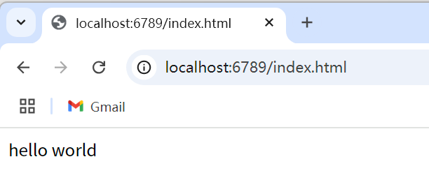
Wireshark Capture – A capture of HTTP request and response exchanges between the client and the server, showing how data is transferred.
Instructions: How to run the program
java WebServer 6789. Open your browser and enter the following URL: http://localhost:6789/index.html
Wireshark
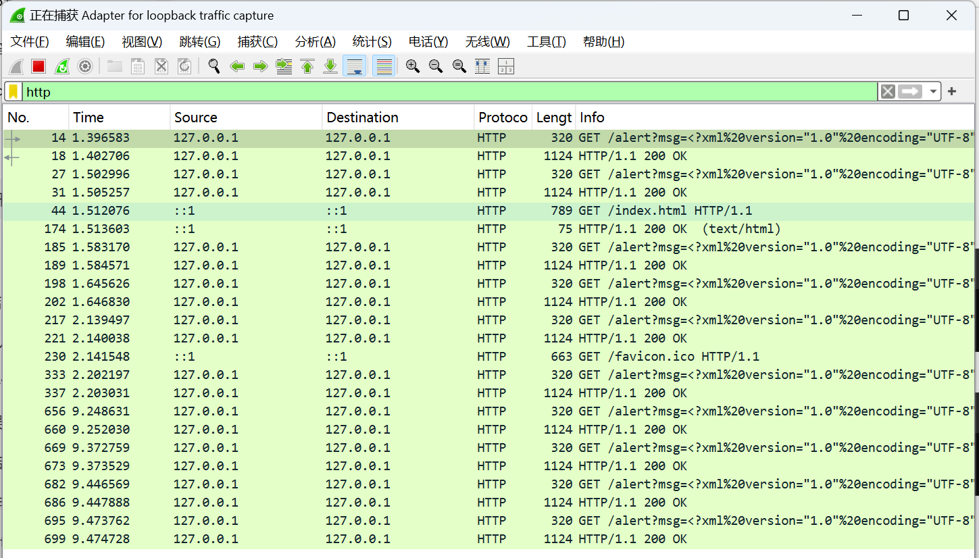
How the program works
Handling Connections: The server listens on the specified port and waits for incoming client connections. When a client connects, the server spawns a new thread using the HttpRequest class to handle the request.

Parsing the HTTP Request: The server parses the HTTP request line and headers. For a GET request, it checks if the requested file exists in the server’s directory.

Sending the Response: If the file exists, the server responds with a 200 OK status and sends the file content. If the file does not exist, it responds with a 404 Not Found message.

Multithreading: Each request is handled by a separate thread, allowing the server to handle multiple client requests simultaneously. This is achieved using the Runnable interface and Java’s built-in thread management.

